IT Project Management – Assignment 2

Comprehensive IT Project Plan Report

**Project Title:** AI-Powered Chatbot Development for Customer Support Automation

# **Introduction**

With everything digital today, customers seek help right away, with all their questions addressed the same way each time. It has become difficult for most customer support systems to keep up with demands for supporting various languages, round-the-clock service and rapid answers from human agents. These drawbacks can irritate consumers and, in turn, add expenses and make things more demanding for workers within the company.

Companies are addressing these difficulties by applying **chatbots** that work using **AI.** Intelligent systems use AI and NLP to interact with people, understand what they ask and provide relevant and well-informed answers. Contrary to live chat, **AI chatbots** can be used by many people, do not fail and communicate instantly and accurately.

This project centers on making, integrating and delivering a top-class AI chatbot that will respond to customers’ inquiries everywhere on the internet. FAQs, guidance on products or services and solving complex incidences by hand are tasks the chatbot will automate. Changes made during implementation will improve efficiency and satisfaction among users.

This project will be aimed at meeting requirements with a focused and flexible process. A clearly stated scope, a detailed Gantt chart, constant control of risks and issues, a regulated process for changes and GitHub for management settings will make the process organized and easy to follow. Essentially, this report covers all parts of the project, including technical and managerial aspects, to ensure successful completion.

# **1. Project Scope Statement**

## 1.1 Project Background:

In such a fast and digitized world, so many companies are looking to provide the best service for their clients at a faster and cheaper rate. The traditional means of customer service are laden with long response times and unstable experiences, not to mention high overheads. Therefore chatbots and AI have been rebirthing organizations in handling 24/7 support while limiting the rigors of human agents. The AI-Powered Chatbot aims to utilize NLP and machine learning methods for the development of an intelligent, smart, adaptive, very reliable support assistant that will help increase customer satisfaction and operational efficiency.

One of the processors involved in maintaining the project quality and controlling it will be the version control handled by GitHub, an excellent platform for source control, collaboration, and documentation tracking. Other processors include the use of a risk management framework to anticipate issues and nullify them, while the change control process will help the team handle scope changes without affecting the project schedule or its deliverables.

The project intends to unfold a completion timeframe of about 4 months and has a budgetary allocation of $100,000. This will serve as a good play of technology, planning, and communication in improving customer experience and building brand loyalty while minimizing the cost of operations in customer support.

## 1.2 The Goals of the Project:

The purpose of this project is to automate customer service using a chatbot that relies on artificial intelligence. The chatbot will be designed to match the company’s plans for digital change and will adopt the existing customer service strategy. The project’s most important objectives are listed below.

1. Automate communicating with customers: It creates a chatbot that can handle around 70% of ordinary customer questions on its own.
2. Ensure There is Help Available Any Time: Provide help to customers day and night, even if they live in different parts of the globe.
3. Integrate your CRM and Helpdesk solution with Revenue: Make sure the chatbot is integrated with helpdesk and CRM tools to allow for individualized and data-based conversations.
4. Improve yourself by using Machine Learning: Use feedback and various sets of training data to help the chatbot learn and improve bit by bit.
5. Increase the Happiness and Interest of Customers: Providing clear and polite responses quickly will help your company gain loyal customers.
6. Reduce custom service budget: Help customers service staff handle cases faster and reduce the overall budget for supporting them. By handling usual queries without an agent, you can reduce the cost of running communication operations.
7. Share Stories on a Range of Online Platforms: Place the chatbot on the website, on apps for phones and connect it with WhatsApp and Facebook Messenger.
8. Make sure data is private and compliant with rules: Regardless of your industry, protect your users’ information by sticking to privacy rules like GDPR.

## 1.3 Essential Results of the Work:

How effectively the AI chatbot functions is determined by meeting the deadlines set for its outcomes. Each item developed for the project makes the system operate smoothly, be usable and be easy to maintain.

1. Business Requirements and Functional Specifications Documents:

These specify both the user and system requirements so that all the stakeholders may share the same understanding concerning the expectations of the project from the starting point.

1. Chatbot System Architecture Diagrams and Technical Documentation:

Graphical representation and documentation of the interaction between architecture components like NLP, backend services, databases, and APIs to provide chatbot functionality.

1. NLP Model with Real Use-Case Data:

An NLP model custom trained on customer queries and data from the domain to create accurate context based responses.

1. Web and Mobile UI Components:

UI components facilitate end-user interaction with the chatbot by desktop and mobile platforms.

1. CRM API Integrations and Ticketing Systems:

The chatbot must be seamlessly integrated with any internal platform such as Salesforce, Zendesk, or Freshdesk that is currently being used to retrieve and update customer data in real-time.

1. Testing Reports of System and Acceptance:

The system and acceptance testing reports include documentation to verify the functional, performance, and contractual requirements of the system.

1. Deployment and Monitoring Guides:

These are step-by-step instructions and best practices on deploying the chatbot into production and monitoring its performance post-launch.

1. Using Manuals and Training Modules:

Used the Training material with easy-to-follow instructions to train customer support agent and Staff.

## 1.4 Assumptions:

Building a project plan involves making some assumptions. Such conditions are necessary for everything to proceed smoothly.

* The client will ensure that training and testing the NLP engine can be done using CRM APIs and anonymized information about customers.
* All resources of the cloud infrastructure (AWS, Azure or Google Cloud) will be prepared and ready to go as outlined in the technical plan.
* During weekly sprint reviews, product managers and domain experts will join in to confirm the achievements made so far.

## 1.5 Constraints:

* **Budget:** The project has strict financial ceiling of $100,000 budget, which includes development, testing, training, and deployment costs.
* **Time:** The entire project must be completed in 4 months (16 weeks).
* **Compliance:** The chatbot must also complete with international security and privacy standards such as ISO 27001 and GDPR to protect delicate customer data.

## 1.6 Exclusions:

A MVP prioritize and connect within time and budget, the following features are out of scope for this project phase:

* Voice Interaction: Speech recognition and voice-enabled chatbot capabilities are not in scope for this version.
* Multilingual Support: English only will be supported for the initial release. Support for other languages will be considered in future phases.

# **2. Gantt Chart Overview and Project Schedule**

The project is phased. Each phase builds upon the previous one to allow a logical and orderly flow.

**Project Timeline Summary**

* Begin Date: Week 1
* End Date: Week 16
* Total Duration: 16 Weeks (4 Months)
* Key Milestones:
* Business Requirements Finalized (Week 1)
* MVP Chatbot Functional (Week 7)
* Full Integration Completed (Week 10)
* User Acceptance Testing (Week 12)
* Final Deployment & Training (Week 16)

## 2.1 Gantt Chart Table

Below is a high-level project timeline breakdown. A detailed Gantt chart indicating resource assignment and dependencies will be created in MS Project or Gantt Project.

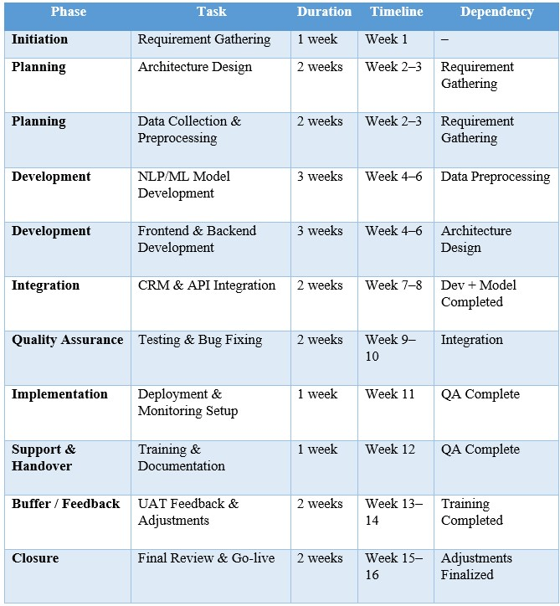

## **2.2 Simplified Gantt Chart Illustration**

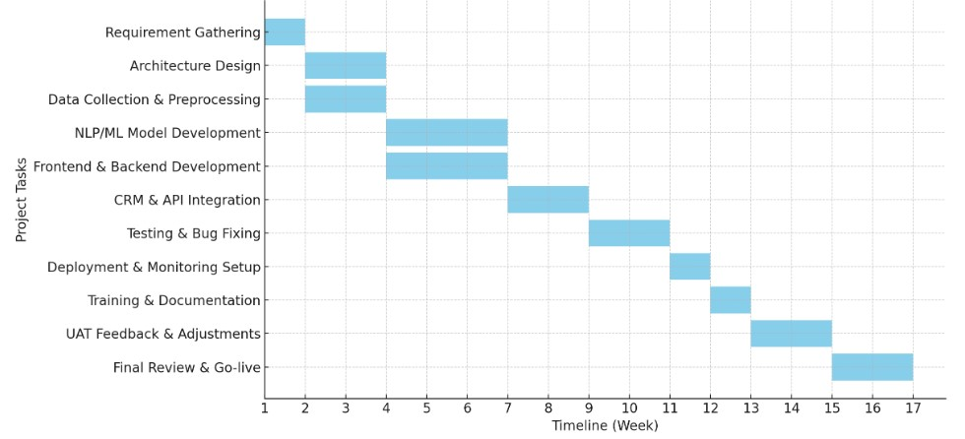

# **3. Risk and Issues Management Strategy**

## 3.1 Risk Identification and Mitigation Plan:



## **3.2 Issue Management Protocol:**

**The organization must follow a protocol for dealing with issues or integrated risk management system.**

* **Put all issues with your project in an issue tracker (GitHub Issues, JIRA, etc.).**
* **Each team member has their own account.**
* **Every incident is handled based on how major, minor or critical it is.**
* **Deadlines for solving each type of case were included.**

## **3.3 Steps in escalation**

**Level 1: The Development Lead is responsible for this role.**

**Level 2: A person in charge of managing projects**

**Level 3: Those in charge of organizing and guiding the project**

# **4. The process for managing change requests**

**Project scope, time and cost should be controlled using a proper process. Here is how the change request process works:**

## **4.1: The Process of Change Requests:**

**1.** Submission request: **A change request form is submitted by the stakeholders with the changes they want and the reason for each.**

**2. Logging: Project Manager writes the change on the Change Request Log.**

**3. Impact Analysis: Factors related to technology, finances and timing are examined.**

**4. Review & Decision: Change Control Board considers and approves, rejects or puts off implementing each change.**

**5. Implementation: The listed changes are added to the product backlog and are scheduled to be implemented.**

**6. Closure: All the changes are recorded and notified to everyone who should know about them.**

## **4.2: An example of a Change Request Log**

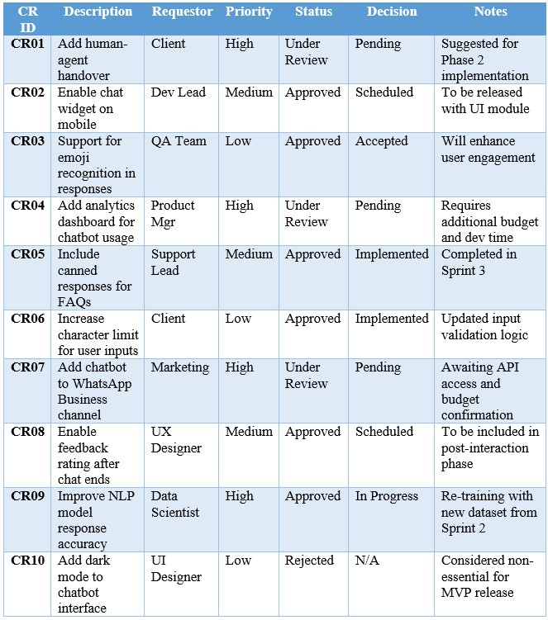

# **5. Managing resource or code configuration via GitHub**

## **5.1: Control, consistency and cooperation are maintained:**

**Proper management of IT projects depends on Configuration Management. It requires you to maintain the same code, documentation, models and scripts throughout the software development process. This AI-driven chatbot will be configured mainly through GitHub. It allows all team members to share a working environment where they can easily follow history, updates, bug reports and documents.**

**GitHub enables:**

* **Keeping records of all changes and being able to fix errors**
* **Relationships among developers, designers and testers**
* **Testing and deploying software can be done automatically using CI/CD systems**
* **Using tools that allow observing progress in issues and going over changes in the code**

## **5.2** The Structure of the Repository is Designed for Flexibility and Expandability

**To handle new ideas and maintain a working team, the repository will be organized in separate blocks. This way of organizing files makes the project easier to understand and navigate for newcomers.**

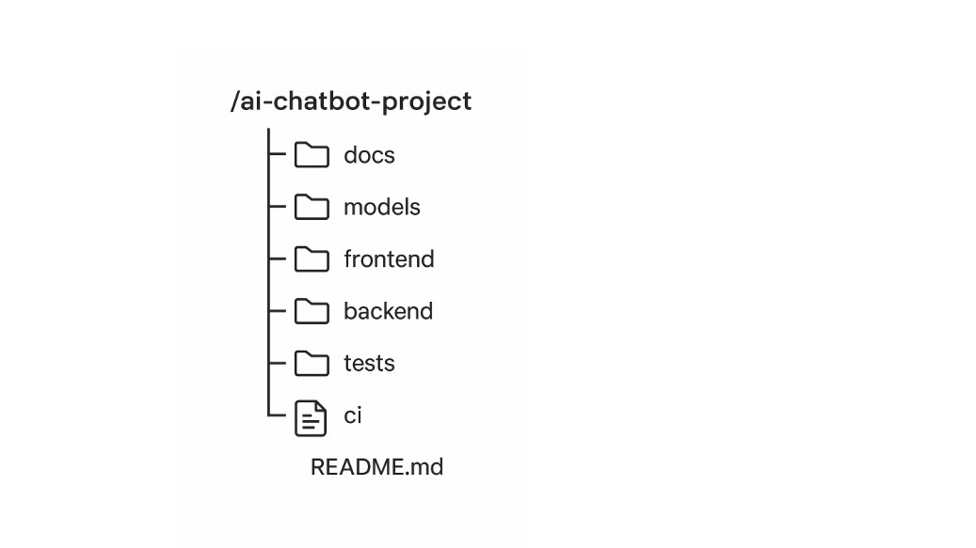**Here, Ai-chatbot-project –**

1. **docs - Requirements, document the design, spec out APIs and provide diagrams**
2. **models- If you use any tools in NLP for previous work, add their NLP scripts, datasets and saved versions of models.**
3. **frontend - Chats using React.js or Vue.js**
4. **backend - Access to our APIs, processing all logic and connecting to our database (with Node.js or Flask)**
5. **tests- Unit, integration and end-to-end test scripts are all written tests.**
6. **ci- GitHub Actions can be used to automate the (build, test, deploy) process.**
7. **README.md - A short description of the project, instructions on how to use it and how to set it up**

**All folders have a defined role and will be handled using the best practices for keeping versions updated. Working in this way, teams are able to develop their own parts without clashing with one another.**

5.3 Following Version Control Practices:  
Version control is not limited to storage. It also helps people communicate. These steps will help ensure quality and prevent confusion when working on several tasks.

Branching Strategy is-

•main – Branch that is secure and includes only stabilized, approved releases  
• dev – Where the main integration takes place and features are checked  
• feature/* – New features are developed in their own isolated branches (e.g., feature/sentiment-analysis)  
• bugfix/* – Immediate solutions for critical issues (for instance, bugfix/login-error)

Commit Guidelines-

**•** Each commit has to follow the format outlined below.

type(scope): message  
For example, I could include a module for analyzing sentiment by using NLP.  
Including the issue numbers for any related tickets helps you keep track of them in the commit history. Looking at pull requests and code.  
**•** None of the code was directly pushed to main. All proposed updates to the code should be done through pull requests. All merges to dev and main must go through a mandatory peer review.

5.4 Keeping a Record: Sharing and Proving Information:

Managing every task, enhancement and bug against the project will happen through GitHub Issues.  
The most effective strategies for handling issues:

• Such as bug, enhancement, urgent, documentation, testing  
• Those who are given accountability and task assignments  
• Connecting challenges with the progress of sprints or various project phases  
• Include checklists in issues for outlining what needs to be done (such as reporting a bug)

All discussions and suggestions for new features will be collected on GitHub, so everyone can follow their progress and see the records.

## 5.5 Using AI to automate CI/CD: Deploying smoothly and quickly

To maintain smooth and error-free delivery, the project plans to rely on CI/CD, using GitHub Actions.

1. **CI (Continuous Integration)**

Every developer’s work on dev or feature/* branches will result in a build very time.

* Test the warehousing system with unit and integration testing.
* Add the code for validating forms both in the frontend and the backend.
* Use of an automated code linter
* CD is short for Continuous Deployment.
* An edge to edge merge means that the code will be pushed to a staging version first.
* Merging to main will involve manual inspection and the subsequent deployment changes to the production environment.

1. The **CI/CD pipeline** guarantees that all of these measures are taken.
   * Decrease in feedback within the system
   * you can Spot bugs as soon as
   * reliable procedures for deploying uniforms
   * Developers have a high degree of certainty regarding.

## 5.6 Keeping Records: Developing a Knowledge Base for Each Version Documentation is important for everyone involved in a project, not only for developers. All the project documentation will be tracked and released using GitHub.

**• /docs:** Contains descriptions of what the systems should do, information about its APIs, chatbot logic, system architecture and security details.  
**• GitHub Wiki:** Will act as an always-changing database of information relevant to the project.  
Inviting the user to start using the platform

All changes made to documents will be versioned, making it possible to trace back their history.

# **Conclusion**

**Making an AI chatbot is an important landmark on the organization’s path to becoming more digital. This is not limited to technological progress. It helps organizations achieve efficiency, cut back on spending and make the customer experience better. Since customer service needs to be effective, trustworthy and beneficial, this project highlights that the company values its customers.**

**The team has shown best practices in how to plan and implement IT projects as part of this initiative. A well-defined scope, a planned schedule, plans for managing risks, approaching changes with flexibility and using GitHub for tracking versions ensure the project will succeed. Adhering to agile methods leads to continuous improvement and offering value at an early stage.**

**Once set up, the chatbot will help customers by providing better support, faster answers, greater options to connect and lowered expenses. In addition, it can be utilized again for similar tasks in HR, IT support and sales.**

**In essence, this project makes use of new ideas, practical skills and on-target action, creating an advantageous position for businesses in today’s market.**